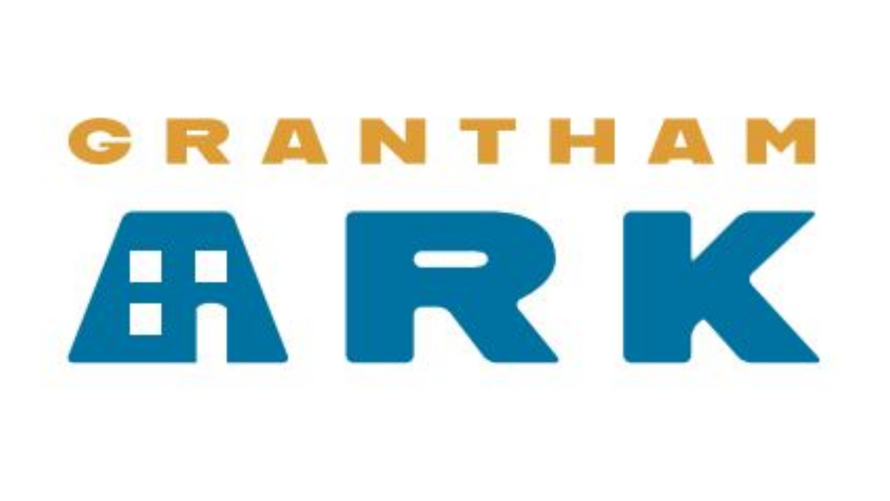
HEALTH AND SAFETY POLICY

1. Purpose
Grantham Ark is committed to creating a safe environment that is the responsibility of all. This policy is to provide and maintain, as far as is reasonably practicable, safe and healthy working conditions for volunteers and guests. Staff and volunteers will all be given appropriate training to ensure that the property is maintained in a safe condition.

Grantham Ark undertakes to:
    - Ensure that health and safety legislation, regulations and codes of practice are observed
    - Provide and maintain safe premises and equipment including appropriate protective clothing
    - Ensure that the use, handling, storage and transportation of food, articles and substances are safe
    - Ensure that the systems of work are safe and provide or locate appropriate training and advice for staff and volunteers in these matters
    - Ensure, as far as is practicable, that all staff, volunteers and guests using the premises are safe and without risk to their health
    - Review and revise this policy annually or as new legislation requires

2. Safety Inspections
The following programme of safety inspection shall be carried out on a regular basis:

At least annually:
    - Risk assessment of the building
    - Independent assessment of the building by District Council housing standards team.
    - Fire procedure and evacuation procedure including visit by registered fire officer
    - Annual PAT test on electrical equipment
    - Gas safety check
    - COSHH (hazardous substances)
    - Insurance

Weekly:
Weekly safety inspections shall be carried out by staff and recorded onto the safety sheet. Any items requiring attention shall be reported back on the house log sheet. (The safety sheet also includes details of all Annual inspections that have been carried out by appropriate independent inspectors and certificates issued).
    - Emergency contact details displayed inside and outside of the building
    - Ensure that fire escape routes are clear
    - Appropriate signage is present and readable - health and safety and information
    - Fire safety check that detectors, extinguishers, fire blanket and emergency lighting are in situ are in full working order
    - First Aid and any safety equipment is fully stocked and available

Guests will also be advised of their duties regarding Health and Safety at the commencement of their occupation.

3. Personal Safety – Do's and Don'ts
In order to promote the safety of all guests, always observe the following rules:
  - Confirm the identity of the guest by asking for their name
  - Do not let any ‘want to be guest’ into the premises
  - Never give your personal phone number or home address to any guest, or arrange to meet them outside of the premises without the express permission of the supervisor.
  - Never invite a guest to your home
  - Do not give or lend money to guests.
  - Avoid entering a guest's room unless accompanied. Meet with them in the communal area
  - Do not bring valuables into the property
  - Do not touch guests to wake them up
  - When dealing with lost property, never put your hand into a bag or pocket. Please tip contents
  - onto a flat surface so you can see what you are handling. This will help to prevent any potential
  - injury.
  - Everyone should act safely and not put themselves or others in any danger.
  - If you feel intimidated at any time inform your Supervisor.

This Policy should not be used for complaints relating to your own personal circumstances, such as the way you have been treated at work. In those cases, you should use the Grievance Policy and Procedure.
If you are uncertain whether something is within the scope of this Policy, you should seek advice from the Trustees.

Review date January 2024

